DSP Assignment Report

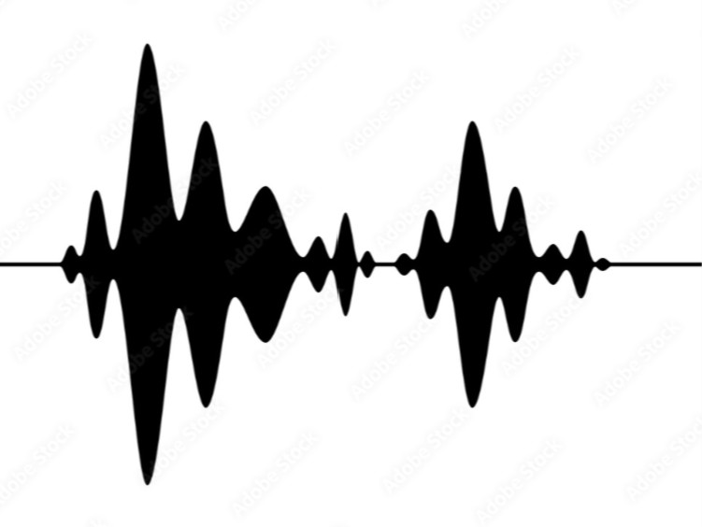
Team Members:
Amr Ashraf - 202101355
Marwan Ahmed – 202101214
Mahmoud Mohamed Elshahed – 202100678

Course: CIE-442 Digital Signal Processing

December 3, 2024

Contents
- Introduction 2
- Pre-processing 2
  - Reading EEG Data . . . . . . . . . . . . . . . . . . . . . . . . . . . . . . 2
  - Channel Selection and Averaging . . . . . . . . . . . . . . . . . . . . . . 2
- Spectrogram Analysis 4
  - Implementation of STFT . . . . . . . . . . . . . . . . . . . . . . . . . . . 4
  - Window Types and Effects . . . . . . . . . . . . . . . . . . . . . . . . . . 4
  - Window Length and Resolution Trade-offs . . . . . . . . . . . . . . . . . 4
  - Overlapping Ratio . . . . . . . . . . . . . . . . . . . . . . . . . . . . . . 4
- Results and Analysis 4
  - Spectrogram Plots . . . . . . . . . . . . . . . . . . . . . . . . . . . . . . 4
  - Discussion . . . . . . . . . . . . . . . . . . . . . . . . . . . . . . . . . . . 4
- Conclusion 5
- References 5

Introduction
The purpose of this report is to investigate spectrograms using the Short-Time Fourier Transform (STFT). This assignment analyzes the effect of window types, lengths, and overlapping ratios, and explores the trade-offs between time and frequency resolution. The EEG signals used in this study were obtained from the CHB-MIT database.
Objective: To develop an analytical system based on spectrograms and investigate their properties using normal and epileptic EEG signals.

Pre-processing

Reading EEG Data
The EEG data was loaded and segmented based on ictal and interictal states as specified in the assignment. We used the following files:
    - chb12 32 data.mat for interictal state
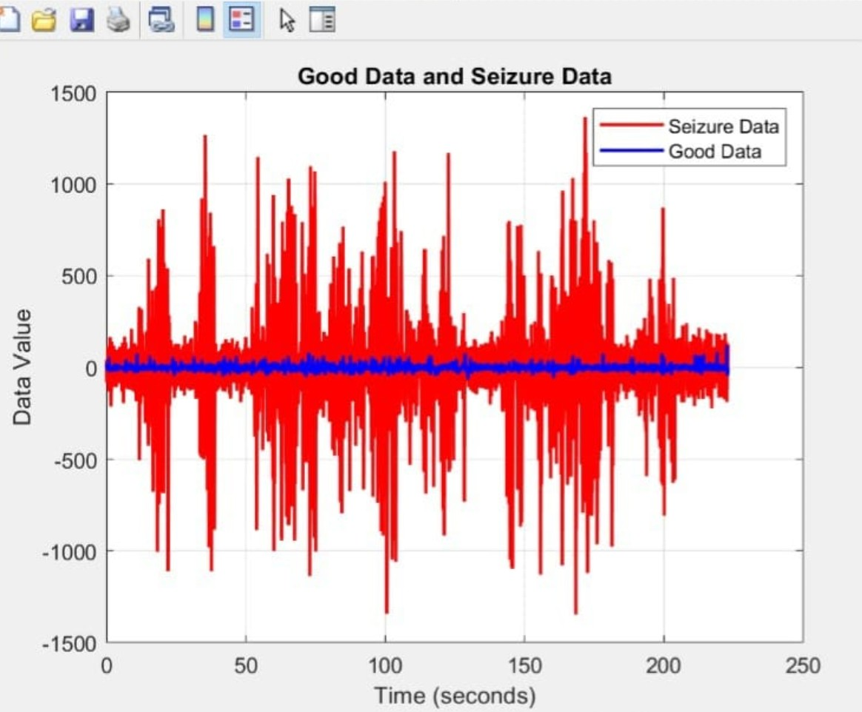
    - chb12 29 data.mat for ictal states
Figure 1: Loaded EEG data from CHB-MIT dataset.

2.2 Channel Selection and Averaging
A user interface was implemented to allow the selection of EEG channels. The selected channels were averaged to create a single representative signal for analysis.

Figure 2: Graphical User Interface (GUI) for selecting parameters and channels.

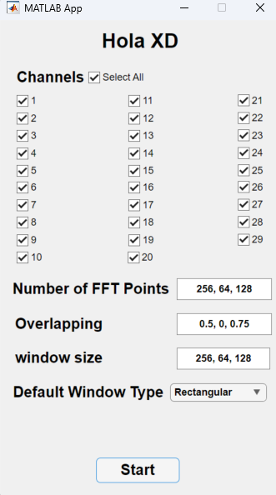
You can select the cannels from the check boxes and then in the text boxes you can put your parameters comma separated

Spectrogram Analysis

Implementation of STFT
The spectrogram was constructed from scratch using FFT on pre-processed EEG data. A sliding window approach was applied, segmenting the signal into n-second frames.

Window Types and Effects
We analyzed the effect of different window types:
    - Rectangular Window: No windowing applied, leading to high spectral leakage.
    - Triangular Window: Moderate leakage reduction.
    - Hamming Window: Balanced approach with lower leakage.
    - Blackman Window: Minimal leakage but reduced frequency resolution. Figures comparing spectrograms with different window types are included in Section 4.

Window Length and Resolution Trade-offs
Changing the window length affects the time and frequency resolution:
    - Short Window: High time resolution, low frequency resolution.
    - Long Window: High frequency resolution, low time resolution.

Overlapping Ratio
We investigated how overlapping ratios between frames impact the continuity of the spectrogram:
    - Low Overlap: Discontinuous spectrogram.
    - High Overlap: Smooth transitions and better representation.

Results and Analysis

Spectrogram Plots

Picking three different window size:

Rectangular window Normal:

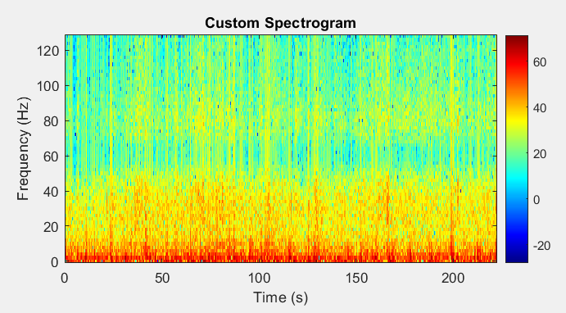

Rectangular window Abnormal:

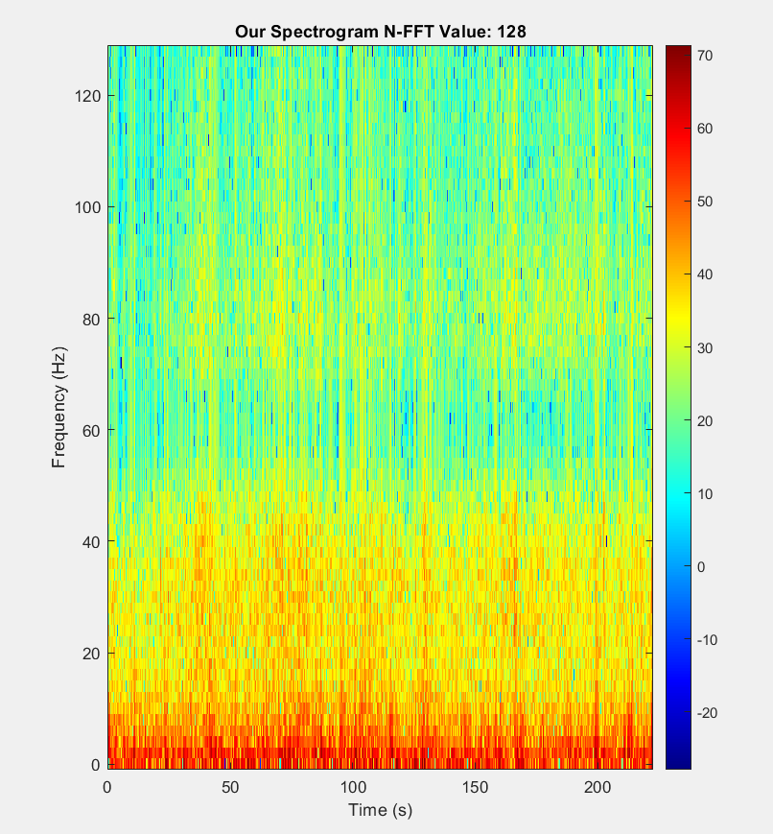

Triangular Window Normal:

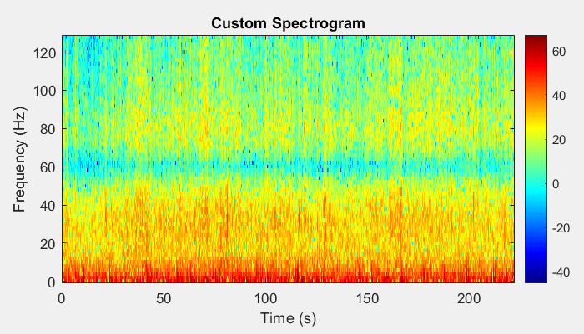

Triangular Window Abnormal:
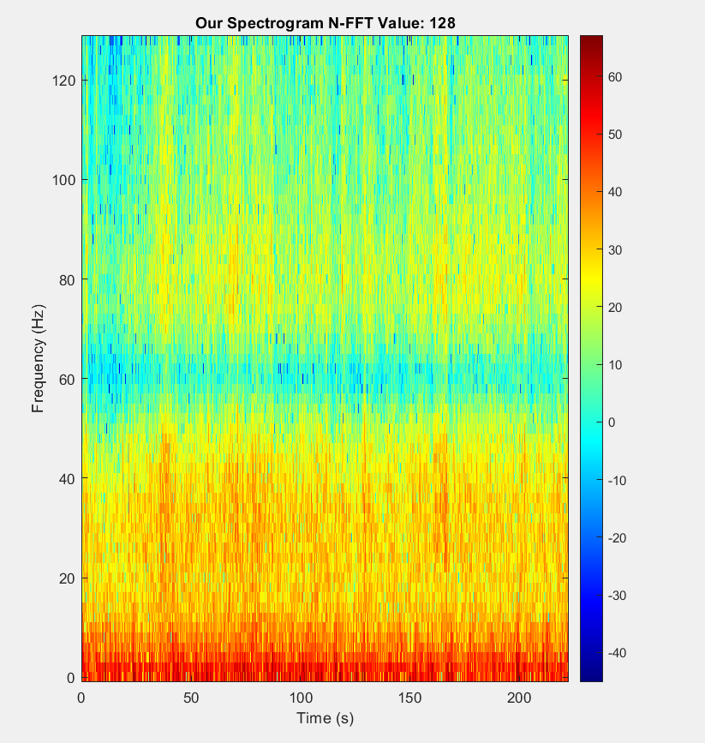

Hamming Window Normal:

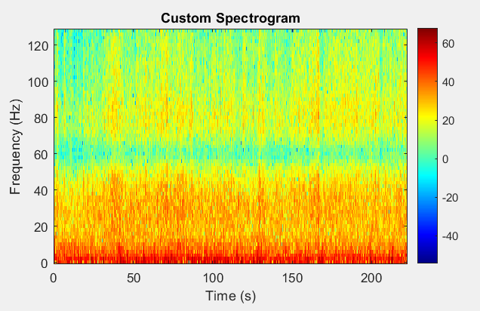

Hamming Window Abnormal:
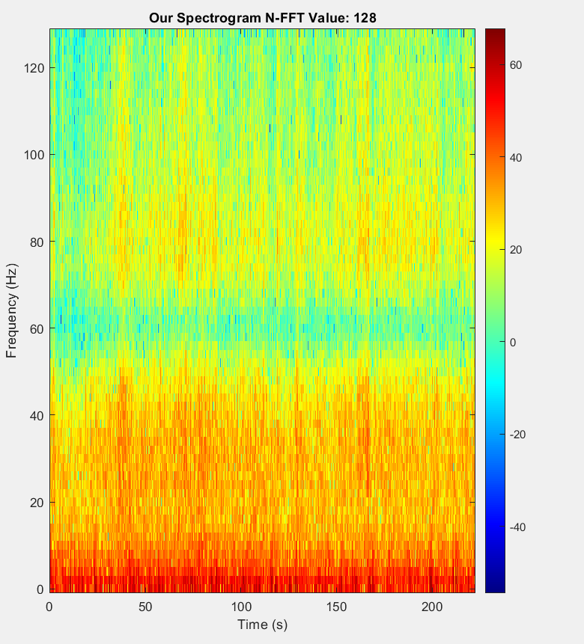

Blackman Window Normal:

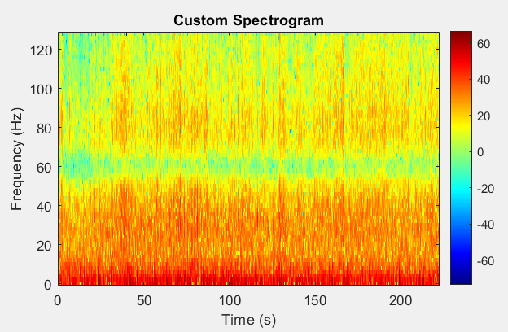
Blackman Window Abnormal:
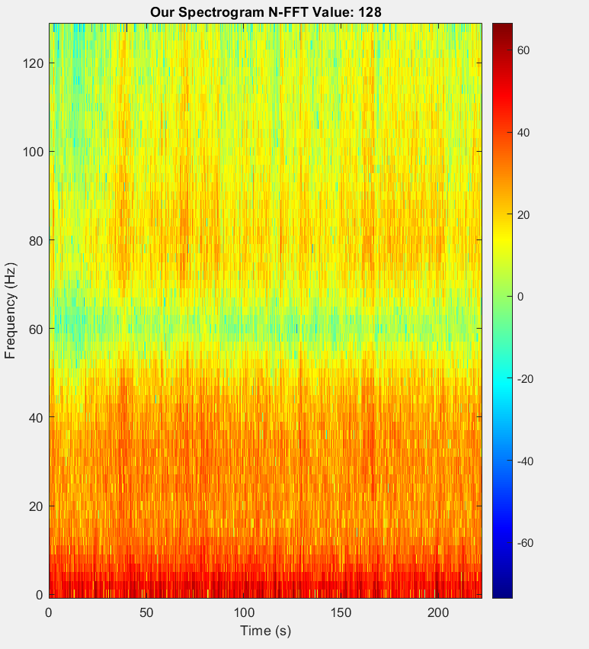

Changing N-FFT Points

N-FFT = 64, Overlap ratio = 0.5, Rectangular Window (Normal)

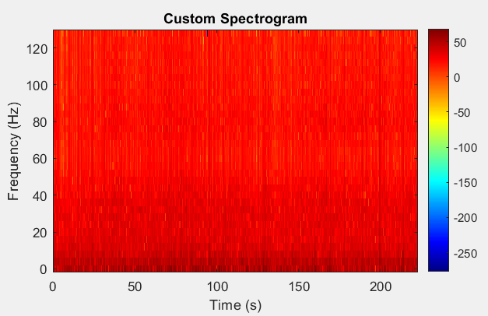

N-FFT = 64, Overlap ratio = 0.5, Rectangular Window (Abnormal)

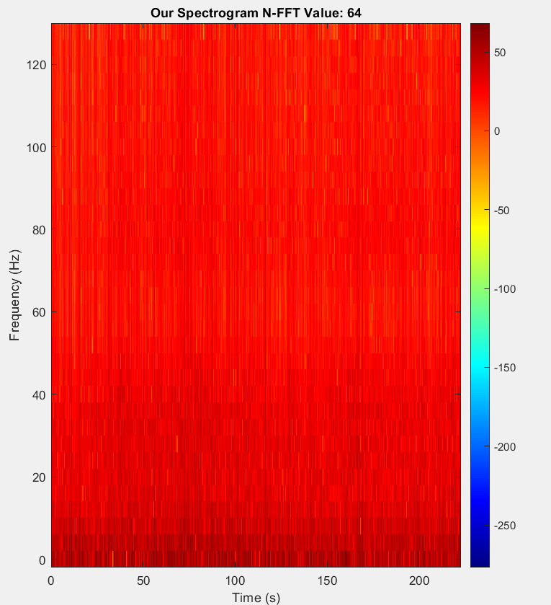

N-FFT = 128, Overlap ratio = 0.5, Rectangular Window (Normal)

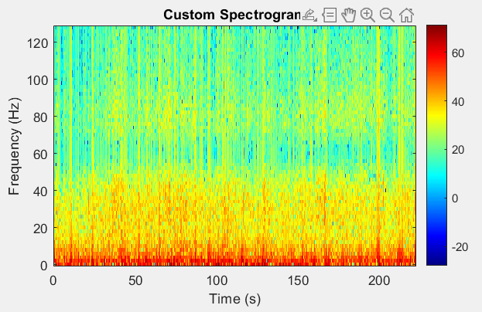

N-FFT = 128, Overlap ratio = 0.5, Rectangular Window (Abnormal)

N-FFT = 256, Overlap ratio = 0.5, Rectangular Window (Normal)

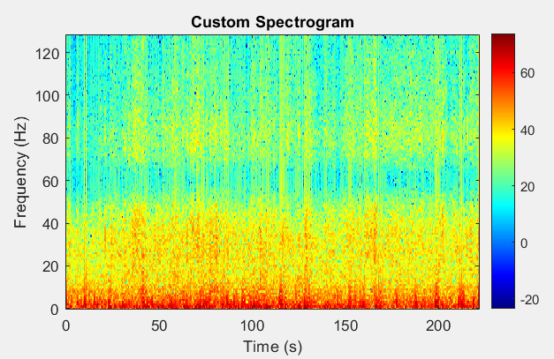

N-FFT = 256, Overlap ratio = 0.5, Rectangular Window (Abnormal)

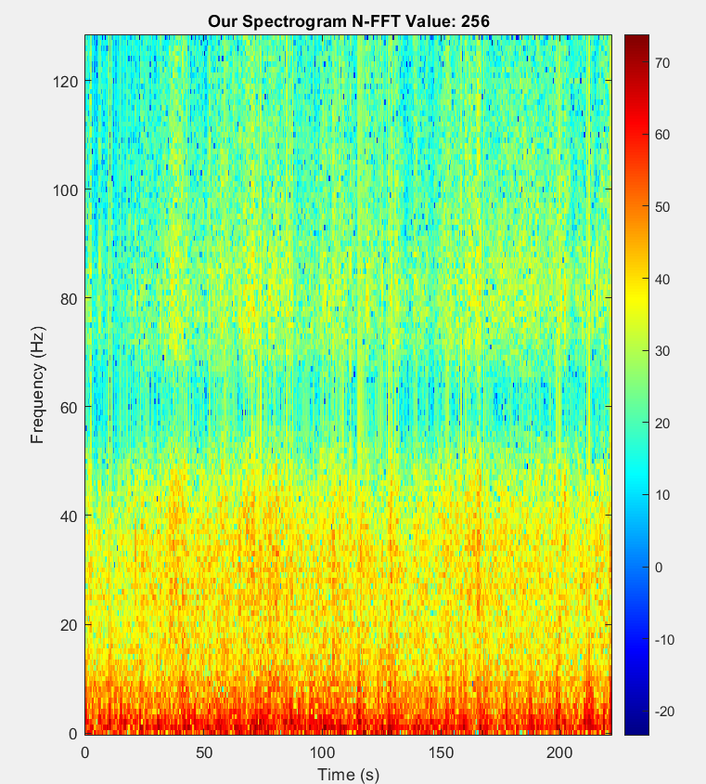

N-FFT = 512, Overlap ratio = 0.5, Rectangular Window (Normal)

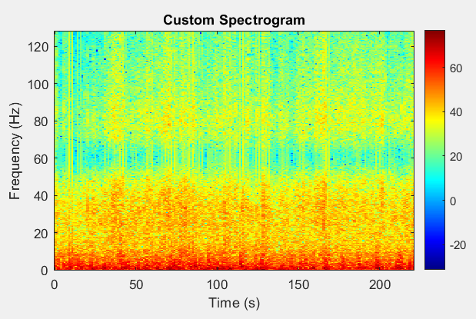

N-FFT = 512, Overlap ratio = 0.5, Rectangular Window (Abnormal)

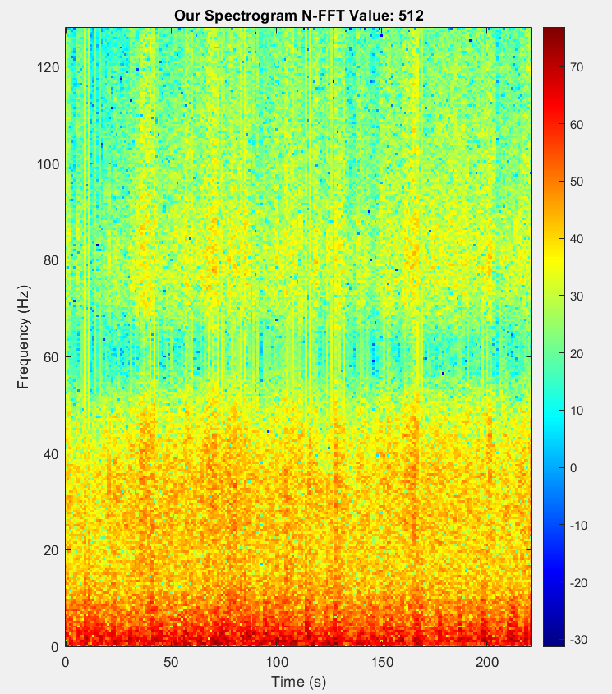

Changing Overlapping Ratio

Rectangular Window, Overlap ratio= 0 (Normal)

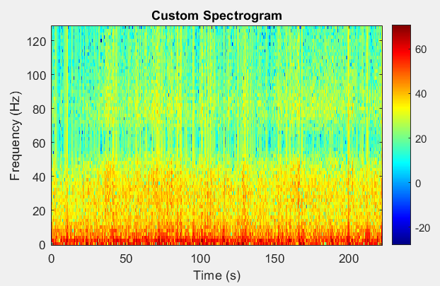

Rectangular Window, Overlap ratio= 0 (Abnormal)

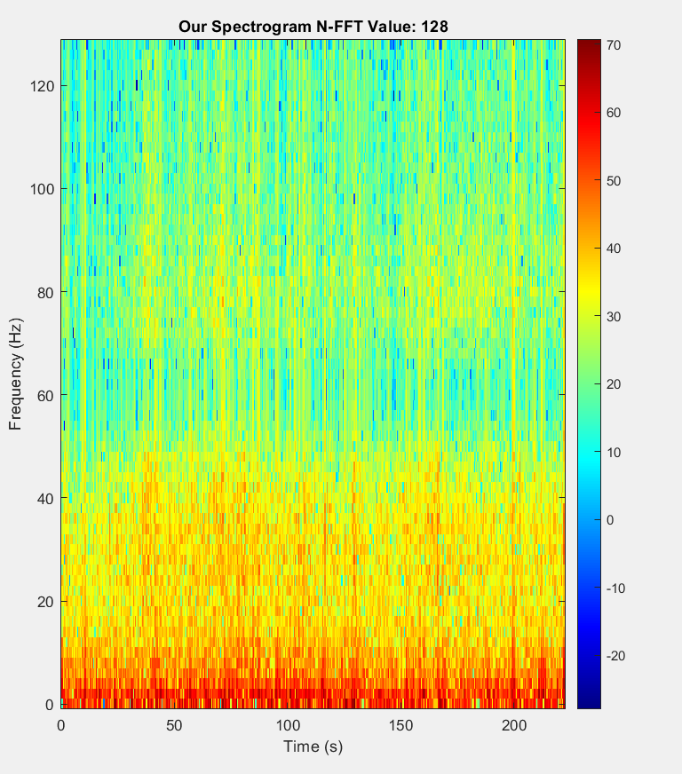

Rectangular Window, Overlap ratio= 0.5 (Normal)

Rectangular Window, Overlap ratio= 0.5 (Abnormal)

Rectangular Window, Overlap ratio= 0.75 (Normal)

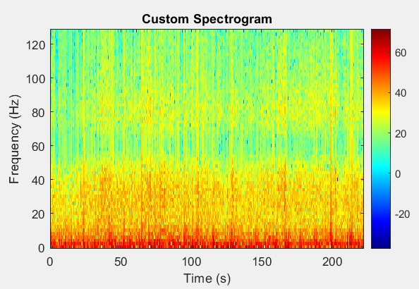

Rectangular Window, Overlap ratio= 0.75 (Abnormal)

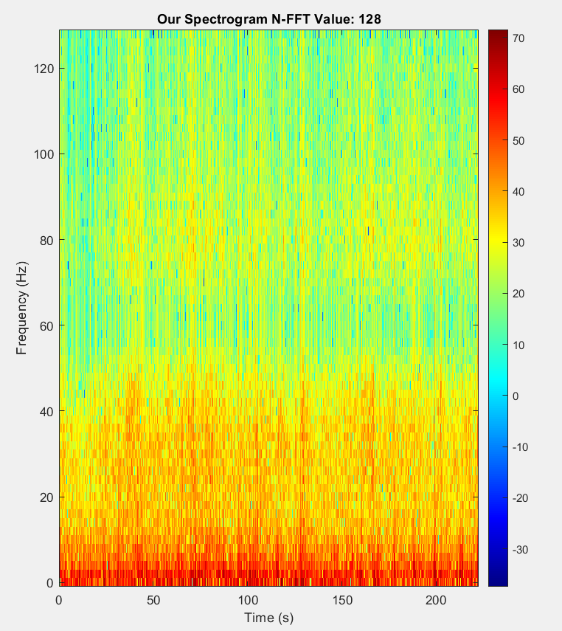

Discussion
The results demonstrate the trade-offs and effects:
    - Window type and size significantly impact leakage and resolution.
    - Overlap improves spectrogram continuity but increases computational cost.

Conclusion
This report explored the construction of spectrograms using STFT and analyzed the effects of window types, lengths, and overlap ratios. These findings are crucial for selecting optimal parameters in EEG signal analysis, particularly in identifying epileptic activity.

References
- CHB-MIT Scalp EEG Database: https://physionet.org/content/chbmit/1.0.
0/
- The Scientist and Engineer’s Guide to Digital Signal Processing, Chapter 16.

